

**SEMESTER TWO 2017**

**Evolution Test:**

**ANSWER BOOKLET**

**NAME: ANSWER KEY**

**FORM:** **DATE:**

Multiple Choice Short Answer Total

**/28**

**/51**

**/23**

**SECTION ONE:** Multiple choice answers

Cross (X) through the correct answer.

|  |  |  |  |  |
| --- | --- | --- | --- | --- |
| **1** | a | b | c | XXX |
| **2** | a | b | c | XXX |
| **3** | XXX | b | c | d |
| **4** | a | XXX | c | d |
| **5** | a | b | c | XXX |
| **6** | a | b | XXX | d |
| **7** | a | b | XXX | d |
| **8** | a | b | XXX | d |
| **9** | a | b | c | XXX |
| **10** | a | XXX | c | d |
| **11** | XXX | b | c | d |
| **12** | XXX | b | c | d |
| **13** | a | XXX | c | d |
| **14** | a | b | c | XXX |

|  |  |  |  |  |
| --- | --- | --- | --- | --- |
| **15** | a | b | XXX | d |
| **16** | XXX | b | c | d |
| **17** | a | b | XXX | d |
| **18** | a | XXX | c | d |
| **19** | a | XXX | c | d |
| **20** | a | b | XXX | d |
| **21** | a | b | c | XXX |
| **22** | a | b | XXX | d |
| **23** | a | b | XXX | d |
| **24** | XXX | b | c | d |
| **25** | XXX | b | c | d |
| **26** | a | XXX | c | d |
| **27** | a | b | XXX | d |
| **28** | a | XXX | c | d |

**SECTION TWO: Short Answer (21 marks)**

Answer the questions in the spaces provided.

_______________________________________________________________________________________

1. A forest has many trees and bushes that produce nuts. This is a major food source for many species, include a particular bird. Birds of this species have a variety in beak shapes ranging from long and pointy to short and hard. The birds with short and hard beaks are able to eat the nuts better than the birds with long and pointy beaks.

What do you expect to happen to this population of birds over time, in terms of what you know about evolution? Address all four principles of natural selection in your explanation. (5 marks)

**There are more birds than food (competition) (1 mark)**

**Some birds have short beaks, others have long beaks (variation) (1 mark)**

**Short beaks are adaptations that help the birds survive (1 mark)**

**Over time, birds with short beaks should live longer and produce more offspring (1 mark)**

**A change in allele frequency will cause short beaks to become more common in the population (1 mark)**

1. Match the following vocabulary terms with the correct descriptions. (6 marks)

|  |  |
| --- | --- |
| 1. Gradualism | A. Multiple species evolving from a common ancestor. |
| 2. Speciation | B. Burst of evolutionary change followed by periods of stability. |
| 3. Punctuated Equilibrium | C. Formation of a new species from a pre-existing species. |
| 4. Divergent Evolution | D. Slow evolutionary changes over a long period of time. |
| 5. Convergent Evolution | E. When two organisms evolve in response to the other. |
| 6. Coevolution | F. When unrelated species evolve similar characteristics because they live in similar environments. |

1. Male peafowl, called peacocks, have long, colourful tail feathers. Among peacocks there is variation in the size, brightness, and pattern of the tail. Scientists observed the mating success of two groups of peacocks. The graph below shows the scientists’ data.

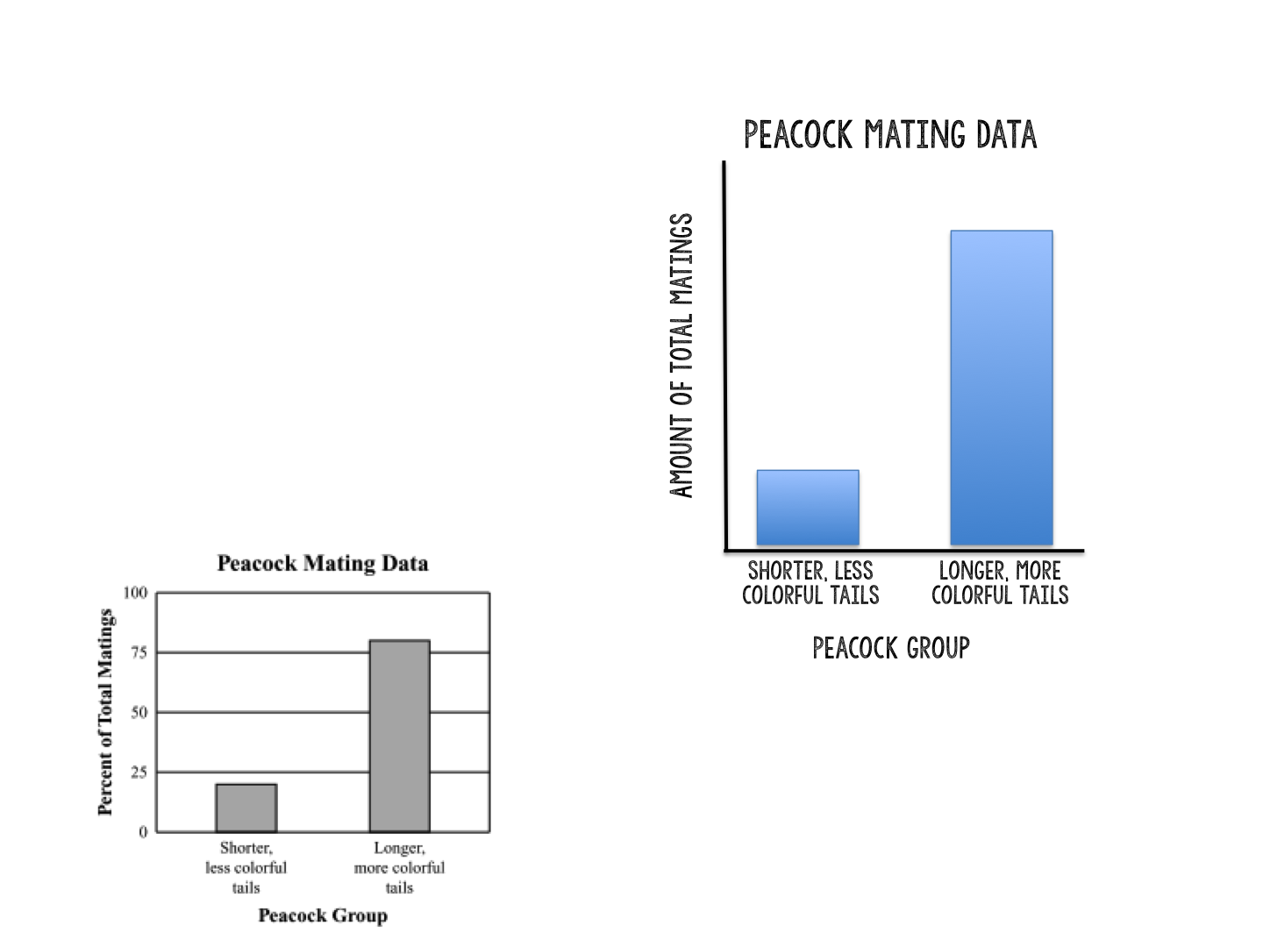

* 1. Explain what the graph shows about the advantage of longer, more colourful tails for peacocks. (1 mark)

**The advantage is that they have an increased amount of total matings**

* 1. Identify **one** disadvantage that longer, more colourful tails may have for peacocks. (1 mark)

**Those with longer, more colourful tails are more easily seen by predators**

* 1. Explain how you think the longer, more colourful tails evolved in peacocks despite causing disadvantages for the males, based on what we’ve learned about evolution. (2 marks)

**Longer, more colourful tails evolved in peacocks due to sexual selection (1 mark)**

**The trait is favoured due to those peacocks with these tails mating more and producing more offspring to carry on the genes, despite the increased risk of not surviving due to predation. (1 mark)**

1. List **two** of the five fields of science discussed in class and why/how they provide evidence for evolution. (4 marks)

**1 mark for area of science, 1 mark for elaboration – Any 2 of the following**

**Biochemistry:** similarities in DNA between different species indicate similarities in ancestry.

**Biogeography**: the same species located on different islands show different traits, indicating evidence of divergent evolution.

**Anatomy**: homologous and vestigial structures in different species is evidence of divergent evolution

**Embryology**: similarities in embryo development of different species indicates that they have a common ancestor

**Paleontology**: fossils help to find the link between extinct species and current species, evidence that species have evolved

1. Use the phylogenetic tree below to answer the following questions: (4 marks)

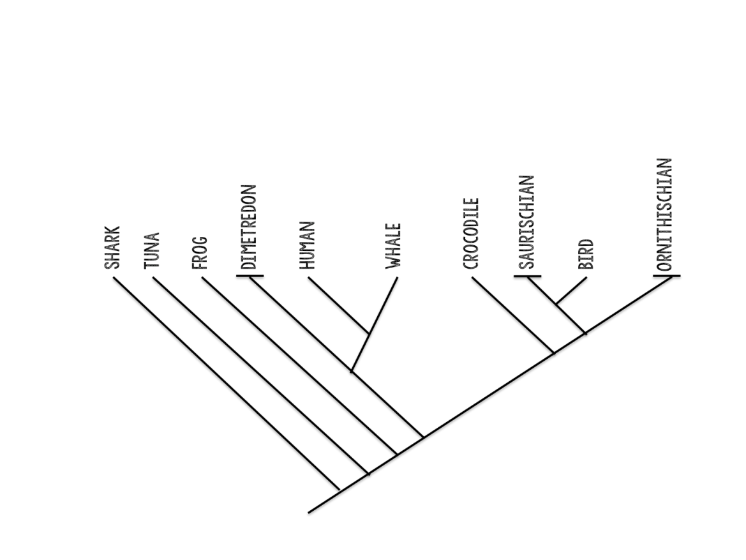

* 1. Which organism diverged first? **Shark**
  2. Who is most closely related to the human? **Whale**
  3. What do all of these organisms share? **A common ancestor**
  4. Is the crocodile more similar in features to the Dimetrodon or the bird? **Bird**